8.40: a) In the notation of Example 8.10, with the large marble (originally moving to the right) denoted as The relative velocity has switched direction, so 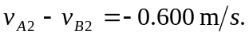 Adding these eliminates 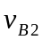 to give with the minus sign indicating a final velocity to the left. This may be substituted into either of the two relations to obtain 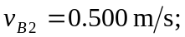 or, the second of the above relations may be multiplied by 3.00 and subtracted from the first to give 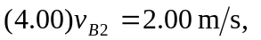the same result.
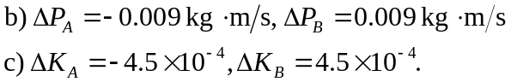
Because the collision is elastic, the numbers have the same magnitude.

